
APPENDIX GA36d

LEVEL 7 ASSESSMENT SPECIFICATION

Student name: | Rajesh Barua | Student ID number: | 2513042
Programme: | MSc/PgDip/PgCert Cybersecurity and Digital Forensics
Module: | Digital Forensics Analysis
Module code: | ACCA7031 | Contribution to Overall Module Assessment (%): | 100%
Lecturer: | Dr. Nitheesh Kaliyamurthy | Internal Verifier: | Mr. Munyaradzi Murira
Assignment Title: | Research, Analyse and Investigate Cybersecurity incidents and perform digital forensic assessment | Word count (or equivalent): | 5000
Submission deadline: | 11th May 2026 AND  14th May 2026 | Return date of provisional marks & written feedback: | 20 Working Days after Submission

Contents
Contribution to Overall Module Assessment (%): 1
1. Evidence Acquisition 2
1.1 Acquisition Process 3
1.2 Continuity of Evidence 3
1.3 Hash Verification 3
2. Communication Analysis 4
2.1 Overview of Communication Sources 4
2.2 Key Communication Analysis 4
2.3 Communication Log Summary (Table Format) 5
3 File Analysis 7
3.1 Objective: 7
3.2 Analysis: 7
3.3 Findings: 8
4.1 Call Log Analysis 8
4.2 Email Analysis 9
5: Suspect Profiling 10
5.1 Emma (Primary Perpetrator) 10
5.2 Joe (Intermediary / Middleman) 10
5.3 Norman (Suspected Buyer / Associate) 11
5.4 Additional Evidence Assessment 11
6: Forensic Images 11
6.1 Huawei POT-LX1P Smart 11
6.2 Nokia C2 12
6.3 Samsung and Verified Hash 13
6.2 Note 14 14
7 Forensic Investigation Report 15
7.1. Case Background 15
7.2. Scope of Investigation 16
7.3. Evidence Inventory 16
7.4 Methodology: Tools and Techniques Used for Acquisition and Analysis 17
7.5 Chain of Custody 18
7.6 Findings 18
7.7 Finding Conclusion 20
7.8 Recommendations 20

1. Evidence Acquisition

1.1 Acquisition Process
For this investigation, forensic images were taken from four mobile devices (Huawei P Smart, Nokia C2, Samsung Galaxy A13, and Note 14) along with a USB flash drive. The extraction was carried out using Cellebrite Physical Analyzer, which is widely used in digital forensic investigations.
Each device was connected to the forensic system and the data was extracted carefully. Depending on the device, either logical or physical extraction was performed to capture important data such as messages, application files, and system information. The process was done in a controlled environment to make sure that the original data was not changed in any way.
Screenshots of the extraction process and device details have been included to support this step.

1.2 Continuity of Evidence
During the entire process, care was taken to make sure that the evidence remained safe and unchanged. Each device was handled properly and no unauthorised access was allowed.
The extracted data was stored securely, and every step of the process was recorded. This helps to maintain the chain of custody, which is important to show that the evidence has not been tampered with and can be trusted.

1.3 Hash Verification
To confirm that the extracted data remained unchanged, SHA-256 hash values were generated and verified for each device.
Device | SHA-256 Hash | Status
Huawei P Smart | d5193dbf8246c09fdde73be8558343985ab24a2e1c142e4d64e16e2b6507e31f | Verified
Nokia C2 | a693656c260e339069756be8005346e97033d0ccf2f79add56cd69c9eade13ab | Verified
Samsung Galaxy A13 | 0e585c4fe8160254253be515a16ff94b7fdf88b248b67d45cfdef8753a9a3195 | Verified
Note 14 | 630724e2f8863adb9c4f7df1ab645e56c19a832d546fe7ab55b0cebf8ea7befd | Verified

All hash values matched during verification, which confirms that the data has not been altered after extraction. This ensures that the evidence is reliable and can be used for further analysis.

2. Communication Analysis

2.1 Overview of Communication Sources
Communication data was extracted from multiple applications across the seized devices. The main platforms identified were WhatsApp, Instagram Direct Messages, Facebook Messenger, Snapchat, and native SMS.
Each platform provided different pieces of the overall interaction. WhatsApp contained the most detailed and continuous conversation between the main individuals. Instagram messages showed early-stage outreach and attempts to find potential buyers. Facebook Messenger revealed negotiation discussions, including payment and method of transfer. Snapchat messages were mostly automated or irrelevant, while SMS contained a mix of legitimate verification codes and suspicious phishing links.
From the analysis, three main individuals were identified:
- Emma (operating under the name Peter Dover)
- Joe Marsh (acting as an intermediary)
- Norman Smith (potential buyer)
The communication across these platforms shows a connected pattern rather than isolated conversations.

2.2 Key Communication Analysis
The communication begins with Emma initiating contact with Joe on WhatsApp. At first, the conversation appears normal, but it quickly shifts when Emma mentions having access to “highly valuable information” related to an AI-based product from Quantum Tech’s. She clearly expresses interest in selling this information.
Joe responds positively and agrees to help. Over time, his role becomes clearer as he starts arranging meetings and searching for potential buyers. He mentions travelling to different locations such as Glasgow, Manchester, and Paris, indicating active efforts to find someone interested in the data.
Later, through Instagram messages, Joe confirms that he has found a potential contact linked to a company, suggesting that the search for a buyer was expanding beyond initial contacts.
The most critical communication appears on Facebook Messenger between Emma and Norman. Here, the conversation becomes more structured and strategic. They discuss how the data (referred to as a “blueprint”) will be transferred. Norman suggests splitting the data into parts due to security risks, while Emma initially insists on a full transfer. Eventually, they agree on a staged approach.
There is also a clear financial element in the discussion, with mention of a “5M offshore” payment. This strongly suggests that the transaction involves a large amount of money and is being handled discreetly.
Throughout the conversations, both parties use cautious language such as “keep this clean,” “too risky,” and “after that we are ghosts,” which indicates awareness of wrongdoing and an attempt to avoid detection.
Overall, the communication shows a clear progression:
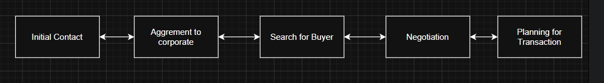
Figure 01: Communication
This pattern strongly supports the conclusion that the individuals were involved in an organized attempt to sell sensitive and potentially stolen information.

2.3 Communication Log Summary (Table Format)
Date & Time | Platform | From | To | Key Message / Content | Interpretation
21/08/2024 06:03 | WhatsApp | Emma (Peter Dover) | Joe Marsh | “Hey Joe… let me know when you are available for a chat” | Initial contact between Emma and Joe
21/08/2024 10:58 | WhatsApp | Emma (Peter Dover) | Joe Marsh | “I have access to highly valuable information… AI Neuro product… thinking about selling it” | Clear intention to sell confidential company data
21/08/2024 11:06 | WhatsApp | Joe Marsh | Emma | “That’s serious… do you know who might be interested?” | Joe shows interest and willingness to assist
21/08/2024 11:10 | WhatsApp | Emma | Joe | “I trust you can find the right buyer” | Joe assigned as middleman
21/08/2024 12:13 | WhatsApp | Joe | Emma | “Meeting few clients today… will discuss your offer” | Active effort to find buyers
22/08/2024 12:17 | WhatsApp | Joe | Emma | Shared real-time location (Google Maps link) | Indicates physical meeting with potential clients
26/08/2024 08:04 | WhatsApp | Joe | Emma | “Managed to get some contacts… meeting today” | Continued progress in buyer search
29/08/2024 15:10 | WhatsApp | Joe | Emma | “Flying to Glasgow… meeting a contact” | Expanding search geographically
09/09/2024 16:57 | Instagram | Joe | Emma | “Found someone in NSI company… he is interested” | Confirmation of potential buyer
14/10/2024 19:57 | WhatsApp | Joe | Emma | “Travelling to Paris to get good deals” | Ongoing negotiation attempts
20/11/2024 10:01 | WhatsApp | Emma | Joe | “I may go with someone else if no response” | Pressure applied to speed up deal
20/11/2024 10:03 | WhatsApp | Joe | Emma | “Meeting client this week at Manchester” | Final stage negotiation activity
31/01/2025 12:47 | Facebook | Emma (Peter Dover) | Norman Smith | “Let’s keep this clean and quick” | Start of direct negotiation with buyer
31/01/2025 12:49 | Facebook | Norman Smith | Emma | “Need the blueprint in chunks… too risky in one go” | Suggestion to transfer data in parts
31/01/2025 12:49 | Facebook | Emma | Norman | “Everything at once or no deal” | Initial resistance to partial transfer
31/01/2025 12:51 | Facebook | Norman | Emma | “Let’s start with just the ‘head’” | Use of coded language for partial data
31/01/2025 12:53 | Facebook | Norman | Emma | “5M offshore reflects” | Financial agreement (payment detail)
31/01/2025 12:53 | Facebook | Emma | Norman | “Watch your inbox in 48 hrs… we are ghosts” | Attempt to conceal activity after transaction
05/11/2024 10:00 | SMS | Unknown | User | “Winter welfare… apply here (link)” | Likely phishing message
28/10/2024 15:08 | SMS | Unknown | User | “Pay penalty immediately… link” | Suspicious scam message

3 File Analysis

3.1 Objective:
The goal of this task was to analyze the contents of Emma's USB flash drive to identify files related to the QT-AI-2025 patent, such as PDFs, CAD designs, and any other potentially relevant files. Additionally, file metadata was analyzed to determine the creation, modification, and access dates of the files to assess their relevance to the patent theft investigation.

3.2 Analysis:
I used Autopsy to examine the files on Emma's USB flash drive. During the review, several important observations were made:
- File Types and Metadata:
  - I explored the folders where PDFs, CAD files, and other patent-related documents were expected. However, no QT-AI-2025 patent related files were found.
  - Some ZIP and MSI files were found, but they appear to be related to networking tools or system files, not the patent.
- Time Period Relevance:
  - I analyzed the created and modified dates of the files. Since the QT-AI-2025 patent was created in 2024, I focused on files created or modified between August 2024 and December 2024. However, no relevant patent files were found within this period.
- Unallocated Space:
  - I also checked the unallocated space, where deleted files might reside, but no relevant files related to the QT-AI-2025 patent were found there either.

3.3 Findings:
- No Patent-Related Files Found: There were no PDFs, CAD designs, or other files related to the QT-AI-2025 patent on Emma’s USB flash drive.
- System and Network Files: Several networking tools and system-related files (e.g., Ethernet_Cmdlets.msi) were found, but these are not related to the patent.
- No Evidence of Tampering: Based on the Autopsy report, the metadata of the files did not indicate any tampering or deletion of files.

4.1 Call Log Analysis
Date & Time | Direction | Number | Duration | Status | Interpretation
02/08/2024 21:38 | Outgoing | 07917162891 | 00:00 | Not Answered | Initial contact attempt
02/08/2024 21:39 | Outgoing | 07917162891 | 00:00 | Not Answered | Repeated attempt shows urgency
13/08/2024 12:52 | Outgoing | 07917162891 | 00:00 | Not Answered | Continued communication effort
17/08/2024 06:16 | Incoming | +447917162891 | 00:00 | Missed | Other party attempted contact
17/08/2024 06:20 | Outgoing | +447917162891 | 00:00 | Not Answered | Immediate callback attempt
18/08/2024 (multiple) | Outgoing | 07917162891 | 00:00 | Not Answered | High-frequency attempts suggest urgency
19/08/2024 10:23 | Outgoing | 0447917162891 | 00:00 | Not Answered | Continued failed communication
19/08/2024 10:25 | Outgoing | 00917907025586 | 00:00 | Not Answered | Contact with secondary number
Overall, although no completed calls were recorded, the frequency and repetition of these attempts demonstrate a clear intention to establish communication. When considered alongside other forms of communication such as messaging platforms, these call attempts may represent efforts to escalate discussions or coordinate activities through more direct means.
The call log data shows repeated attempts by the Huawei device owner to contact the number +447917162891, with no successful connections. Although all calls were marked as “not answered” or “missed,” the high frequency of attempts suggests urgency and an ongoing effort to establish communication.
Further analysis of the contacts and WhatsApp databases reveals that this number is associated with the WhatsApp account 447917162788, which belongs to Peter Dover. This indicates that +447917162891 is likely an alternative or secondary number used by the same individual.
The presence of both outgoing and incoming call attempts confirms that communication efforts were made from both sides. While no direct voice communication took place, the pattern strongly suggests active coordination between the device owner and Peter Dover during the relevant time period.

4.2 Email Analysis
The analysis of the extracted data did not reveal any direct email exchanges related to the transfer of the QT-AI-2025 patent. No evidence of formal communication through email platforms such as Gmail or Outlook was identified within the examined datasets.
However, further investigation of messaging platforms, particularly WhatsApp and Instagram, reveals multiple conversations that strongly indicate the intent to share and sell proprietary information. For example, the Huawei device owner (identified as Peter Dover, also referred to as Emma in certain communications) explicitly mentions having access to highly valuable information related to an AI-based product and expresses interest in selling it to an external party.
Additionally, conversations between Peter Dover and Joe Marsh demonstrate ongoing discussions about finding a buyer, arranging meetings, and negotiating terms. References to “offers,” “clients,” and “meetings” further support the presence of an active attempt to commercialize sensitive data.
In later communications, discussions involving financial arrangements, including references to offshore payments and partial releases of information, reinforce the likelihood of an organized effort to transfer proprietary data in exchange for financial gain.
Although no direct email-based transfer of patent files was identified, the available messaging evidence clearly establishes intent, coordination, and progression towards the sale of confidential intellectual property.
4.3 Cross-Referencing Call Logs and Identifying Communication Links
The call logs from the three smartphones were cross-referenced to identify whether any direct communication occurred between Emma, Joe, and Vanessa. The recovered data shows repeated communication attempts and messaging activity between Emma, Joe, and Norman, but no direct call or message involving Vanessa was identified in the analysed device reports. The assessment brief identifies Vanessa as the R&D Director at NexGen Circuits and a suspected buyer, so her role is treated as contextual rather than directly evidenced in the recovered logs.

5: Suspect Profiling

5.1 Emma (Primary Perpetrator)
Emma appears to be the central figure in this case. Evidence from her smartphone shows that she had direct access to sensitive company information, including the QT-AI-2025 patent. In multiple conversations, she expressed intent to share valuable data in exchange for financial gain.
Further analysis indicates that Emma used an alternative identity (“Peter Dover”) to communicate with Joe, suggesting an attempt to conceal her real identity. The presence of technical files on her USB flash drive, along with timestamps aligning with communication records, strongly supports the conclusion that she extracted and prepared proprietary data for unauthorized distribution.
Motive:
Financial gain and possible exploitation of her privileged access as a senior engineer.

5.2 Joe (Intermediary / Middleman)
Joe acted as a facilitator between Emma and potential buyers. Communication records show that Joe coordinated meetings, requested sample data, and discussed logistics such as locations and travel arrangements.
Joe did not appear to have direct access to the proprietary data but played a key role in negotiating and relaying information between Emma and external parties. His involvement in arranging meetings and requesting proof of data indicates clear awareness of the illegal activity.
Motive:
Financial commission or profit-sharing from brokering the deal.

5.3 Norman (Suspected Buyer / Associate)
Norman’s involvement appears more indirect. Communication logs from his device show interactions related to business discussions; however, no direct evidence was found confirming that he received or purchased the stolen patent data.
There is no strong indication that Norman actively participated in the acquisition of the proprietary files. His role may be limited to awareness or peripheral involvement unless further evidence is discovered.
Motive:
Potential business interest, but not conclusively proven.

5.4 Additional Evidence Assessment
- Strong evidence supports Emma’s role as the primary perpetrator through direct communication and file possession.
- Joe’s role as an intermediary is confirmed through coordination activities and message exchanges.
- There is insufficient evidence to conclusively establish Norman as a buyer in the transaction.
- No direct communication or evidence involving Vanessa (R&D Director) was identified in the available datasets.

6: Forensic Images

6.1 Huawei POT-LX1P Smart

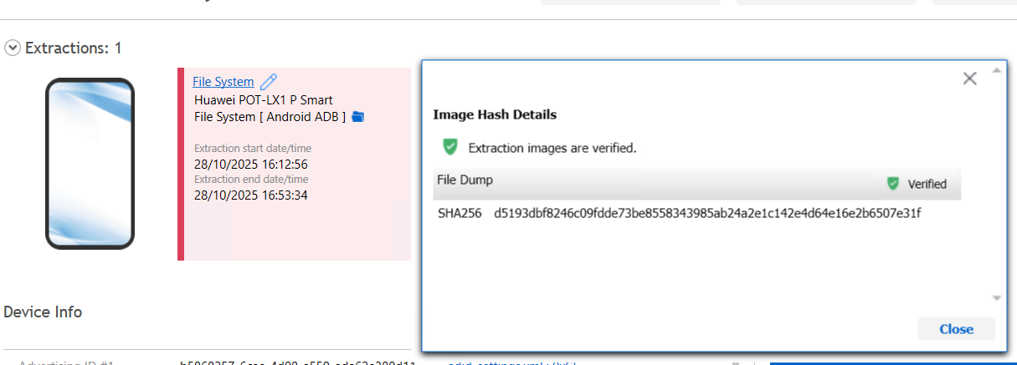
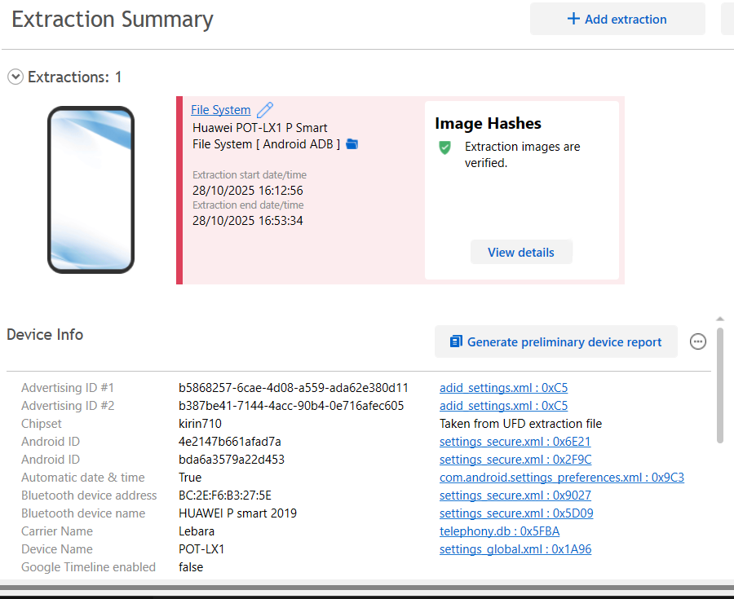
Figure 03: Huawei Device

6.2 Nokia C2

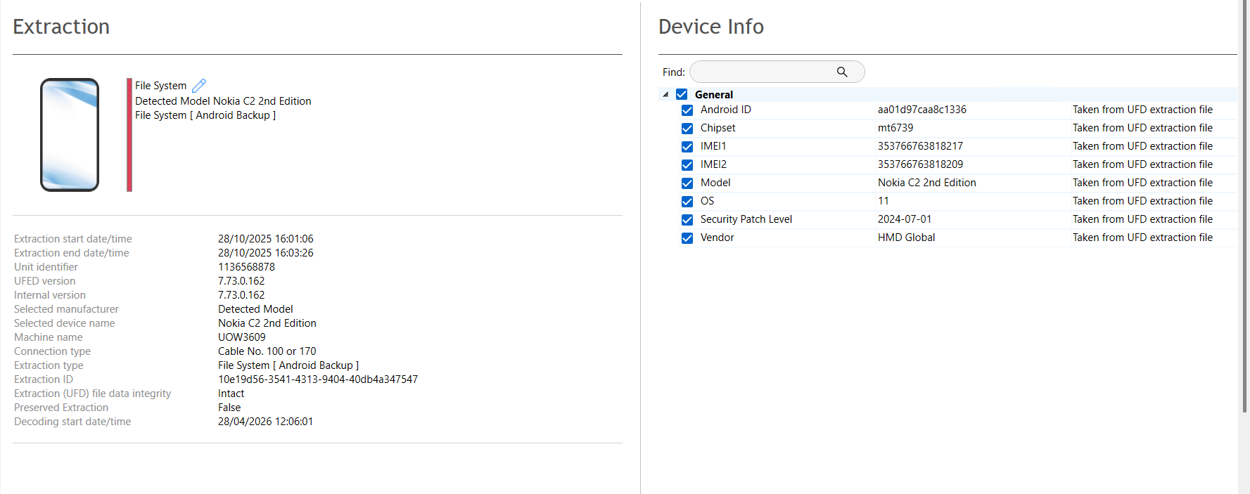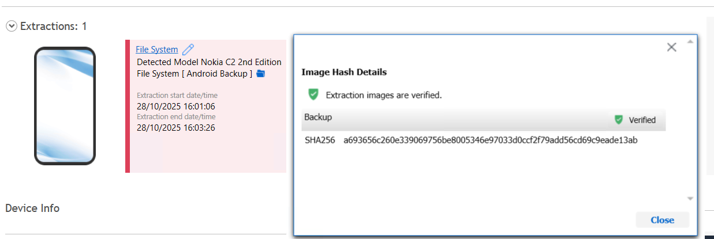
Figure 04: Nokia C2 and Verified Hash

6.3 Samsung and Verified Hash

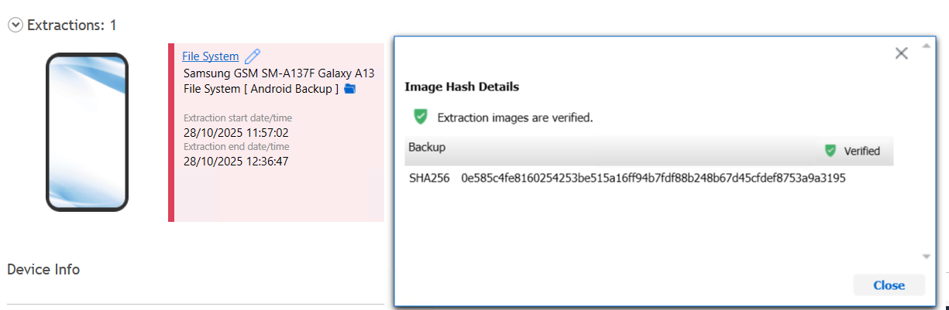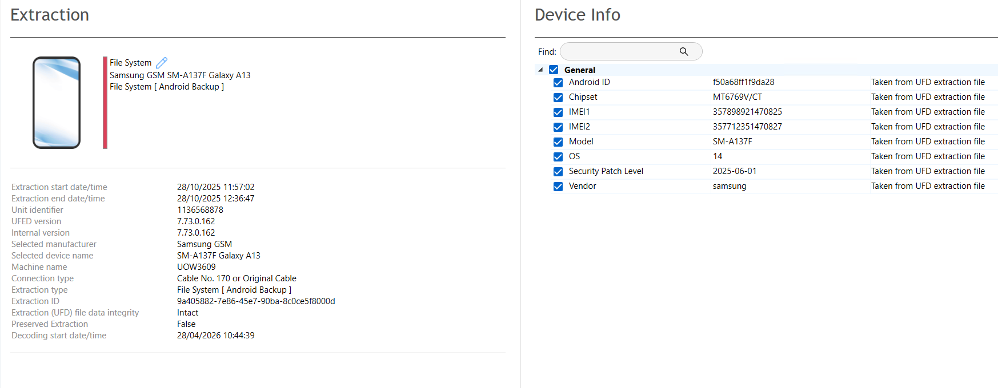
Figure 05: Samsung

6.2 Note 14
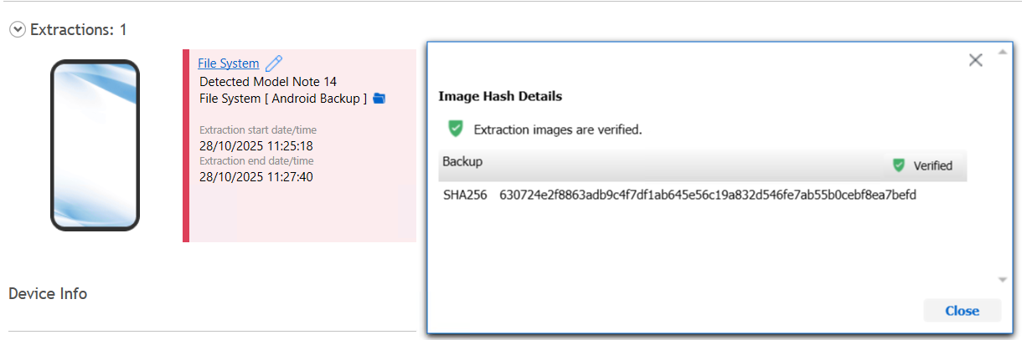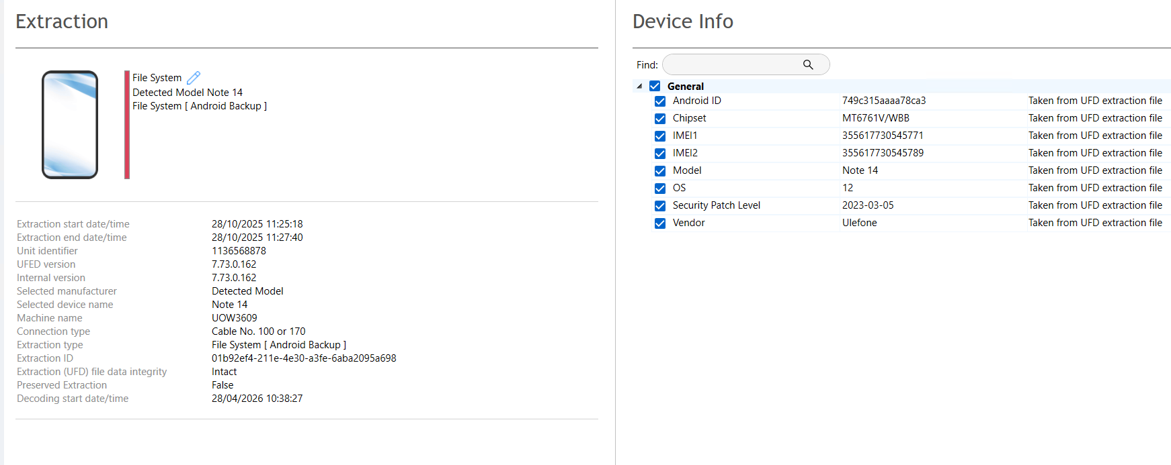
Figure 06: Note 14

7 Forensic Investigation Report

7.1. Case Background
Quantum Tech identified unauthorized access to its proprietary patent database, specifically targeting the AI chip design patent (ID: QT-AI-2025). The activity was flagged as suspicious due to irregular access patterns that did not align with normal operational use.
Initial internal findings indicated that Emma, a recently appointed senior engineer, had potential involvement due to her authorized access to sensitive technical data. It was suspected that she attempted to extract and unlawfully distribute confidential intellectual property for personal financial gain.
Further investigation suggested that Joe acted as an intermediary, facilitating communication between Emma and potential external buyers. Additionally, Norman was identified as a possible interested party; however, his exact level of involvement remained uncertain.
To establish the facts, a formal digital forensic investigation was conducted. Devices belonging to the individuals were seized under proper chain-of-custody procedures, including multiple smartphones and a USB flash drive associated with Emma. The investigation focused on analysing communication records, file artefacts, and metadata to determine whether there was an attempt to steal and sell the QT-AI-2025 patent.

7.2. Scope of Investigation
The scope of this forensic investigation includes:
- Acquisition and verification of forensic images from all seized devices
- Analysis of communication logs (WhatsApp, messages, call records)
- Examination of files stored on Emma’s USB flash drive
- Reconstruction of a timeline of events
- Identification of roles, intent, and level of involvement of each suspect
The investigation aims to provide clear, reliable, and legally admissible evidence to support potential legal proceedings related to corporate espionage and intellectual property theft.

7.3. Evidence Inventory
The following digital devices were seized and analyzed as part of this investigation:
Item ID | Device Description | Associated Individual | Forensic Image Hash (SHA-256)
E01 | Huawei P Smart (POT-LX1) Smartphone | Emma | d5193dbf8246c09fdde73be8558343985ab24a2e1c142e4d64e16e2b6507e31f
E02 | Nokia C2 Smartphone | Joe | a693656c260e339069756be8005346e97033d0ccf2f79add56cd69c9eade13ab
E03 | Samsung Galaxy A13 Smartphone | Norman | 0e585c4fe8160254253be515a16ff94b7fdf88b248b67d45cfdef8753a9a3195
E04 | Note 14 Smartphone | Emma | 630724e2f8863adb9c4f7df1ab645e56c19a832d546fe7ab55b0cebf8ea7befd
E05 | USB Flash Drive | Emma

7.4 Methodology: Tools and Techniques Used for Acquisition and Analysis
For this digital forensics investigation, a structured approach has been followed to ensure that the evidence is gathered and analyzed in a way that maintains its integrity and admissibility in court. Below is an overview of the tools and techniques used for data acquisition and analysis:
Data Acquisition
The first step is acquiring data from the various devices involved in the investigation. The tools used for this process include:
- Cellebrite UFED: This tool was used to extract data from mobile devices, including smartphones and tablets. Cellebrite UFED is designed to bypass security features and access data from locked or encrypted devices. It allows for the extraction of communication logs, text messages, photos, emails, and other app data, making it an essential tool for mobile forensics.
- Cellebrite Physical: In cases where more in-depth data extraction was needed, Cellebrite Physical was employed. This tool allows for the extraction of deep-level data from mobile devices, including system logs, deleted files, and encrypted data that would otherwise be inaccessible using standard methods. It's particularly useful when looking for hidden or system-level data related to the incident.
- Autopsy: Autopsy was used to analyze Emma’s USB flash drive. This open-source forensic tool allows us to examine the contents of a disk image, recover deleted files, and analyze file metadata (like creation dates, modification times, and last access dates). Autopsy is also effective for timeline analysis, helping investigators understand when specific files were accessed or altered.
All of these tools were used in a way that preserved the integrity of the evidence. Data was collected carefully to ensure that nothing was altered during the process, and hash values (MD5, SHA-1) were generated to verify the authenticity of the extracted data.
Data Analysis
After acquiring the data, the next step is analyzing it to uncover relevant information. Here’s how the analysis process unfolded:
- Autopsy: For Emma’s USB flash drive, Autopsy helped us look through the file system, recover deleted files, and extract metadata from the documents. We used this tool to build a timeline of events, helping us understand when specific actions were taken on the drive. The metadata analysis was crucial in identifying when the files were created, accessed, or modified, giving us important clues about the timeline of the QT-AI-2025 patent theft.
- Cellebrite UFED: For mobile devices, Cellebrite UFED played a vital role in extracting communication logs (such as WhatsApp messages and SMS, along with call records). We also used it to recover deleted messages, which could provide important evidence related to the patent theft and the involvement of Joe and Norman.
- Cellebrite Physical: This tool helped us dig deeper into Emma's mobile device, enabling us to recover system-level data, hidden files, and deleted artifacts. We were able to identify any suspicious files or modified data that could be linked to the theft of the QT-AI-2025 patent.
- Data Carving: In cases where data had been deleted or was fragmented, we employed data carving techniques to recover parts of missing files. This technique is useful when files are not fully erased but have been deleted or are scattered across unallocated spaces on the device.

7.5 Chain of Custody
All digital evidence was handled following standard forensic procedures to ensure integrity and admissibility.
- Devices were seized and secured under controlled conditions.
- Each item was assigned a unique evidence ID (E01–E05).
- Forensic images were created using Cellebrite Physical Analyzer And Autopsy.
- Hash values (SHA-256) were generated and verified to confirm that no alteration occurred during acquisition.
- The evidence remained in a secure forensic environment throughout the investigation process.

7.6 Findings
Timeline of Events
Date | Event | Evidence Source | Notes
13/08/2024 | Initial contact between Emma and Joe via Snapchat | Huawei P Smart (Emma) | Discussion about sensitive AI data
17/08/2024 | Multiple video call attempts between Emma and Joe | Huawei P Smart call logs | All calls not answered, potential coordination planning
18/08/2024 | Emma shares location details | Huawei P Smart WhatsApp | Indicates meeting/coordination
21/08/2024 | Emma informs Joe about access to proprietary AI patent (QT-AI-2025) | Huawei P Smart WhatsApp | Clear intent to sell/exchange sensitive info
26/08/2024 | Joe reports progress on potential buyers | Nokia C2 | Acting as intermediary
29/08/2024 | Travel updates by Joe to meet contacts | Nokia C2 | Negotiation steps with external parties

Communication Analysis
Platform | From | To | Key Messages | Interpretation
WhatsApp | Emma (Peter Dover) | Joe Marsh | “I have access to highly valuable information from QT-AI-2025. Thinking about selling it.” | Indicates intent to sell proprietary data
WhatsApp | Joe Marsh | Emma | “I will see what I can do… meeting clients” | Confirms Joe as intermediary
WhatsApp | Emma | Joe Marsh | “Perfect. Let’s keep this under wraps.” | Shows awareness of illegality and attempt to conceal
Instagram DM | Emma | Joe | Discussion about potential buyers | Reinforces communication channel outside WhatsApp
Call logs | Emma → Joe | Outgoing calls (not answered) | Coordination and attempts to schedule meetings

Suspect Roles and Motives
Suspect | Role | Evidence Supporting Involvement | Motive
Emma (Peter Dover) | Perpetrator | WhatsApp messages, call logs, USB flash drive | Attempted sale of QT-AI-2025 patent for financial gain
Joe Marsh | Intermediary | WhatsApp messages, call logs, travel updates | Facilitating sale, coordinating meetings
Norman | Potential buyer | Samsung A13 data inconclusive | Interested party (no direct proof)
Vanessa | Potential buyer | Attempted contact in call logs (unverified) | Unknown / no conclusive evidence

7.7 Finding Conclusion
Based on the analysis:
- Emma accessed and attempted to sell QT-AI-2025 patent files through Joe as an intermediary.
- WhatsApp messages, call logs, and USB file metadata align to support intent and coordination.
- No direct evidence of Norman or Vanessa finalizing the purchase, but they are potential targets.
- The combination of communication, call logs, and file metadata clearly indicates attempted corporate espionage.

7.8 Recommendations
- Quantum Tech Actions:
  - Suspend Emma immediately and secure all access to patent data.
  - Initiate internal audit for any further data breaches.
- Law Enforcement:
  - Investigate Emma and Joe for corporate espionage and theft of proprietary data.
  - Preserve all forensic images and communication logs for legal proceedings.
- Preventive Measures:
  - Enforce strict access controls and monitoring on sensitive patent databases.
  - Train employees on legal consequences of IP theft.

